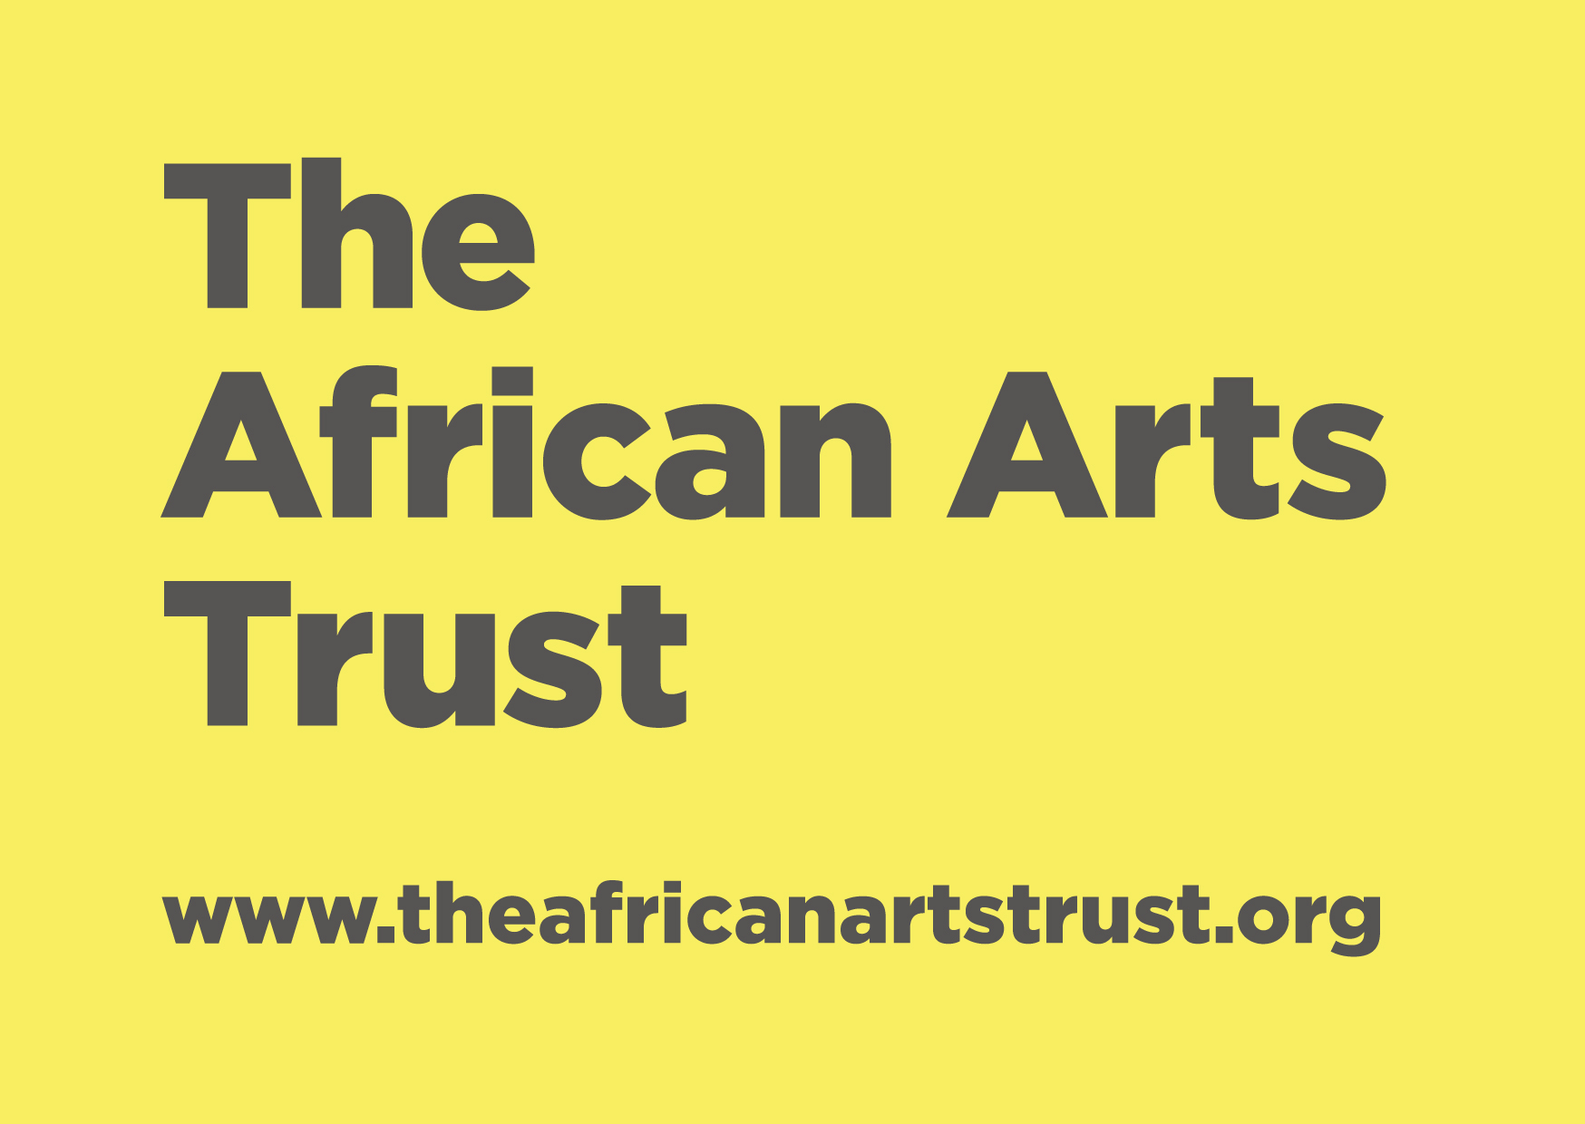 Initial Questions for Applicants

Name of your organization

Name of main point of contact and their position within the organization:

Contact details: email, phone number, website, facebook page etc.

Are you an organisation or individual?
Are you officially registered?

If Yes, which of the following is your organisation registered as?
What arts organisations and artists do you collaborate with in your area?
Is your organisation based in Africa?  If No, where are you based?  If Yes, what Country/Region? | Yes or No
Is the focus of your organisation visual arts?

Do you work with professional visual artists?

Are you a community or outreach based organisation?

What amount are you requesting from TAAT?

When is the date you require funding to start?

Have you secured other funding partners or applied for other funding?
If Yes, where from?

Summarise your organization in one paragraph, (200 words)

Summarise the project or activities that you are looking for funding for - in one paragraph, (200 words) please be specific

*Please note, you will only hear from TAAT in response to this questionnaire if you have successfully reached the next stage of the application.

